**Project Design Phase**

|  |  |
| --- | --- |
| Date | 30 june 2025 |
| Team ID | LTVIP2025TMID59822 |
| Project Name | Hematovision: Advanced Blood Cell Classification Using Transfer Learning |
| Maximum Marks | 4 Marks |

The Project Design Phase focuses on converting insights and requirements from the ideation phase into a practical, structured plan. This phase outlines the system architecture, data flow, component design, and user experience, ensuring a solid foundation for implementation.

**3.1 System Architecture**

The system is composed of the following key components:

* Frontend Interface: A web-based UI built using HTML, CSS, and Bootstrap, allowing users to upload blood cell images and view classification results.
* Backend Server: Developed using Flask (Python), handles image processing, prediction, and communication with the trained model.
* Deep Learning Model: A CNN model trained using transfer learning (e.g., with MobileNetV2 or VGG16), stored as a .h5 file for deployment.
* Database (Optional): Used to log user inputs, results, and store feedback for future model improvement.

**Architecture Diagram**

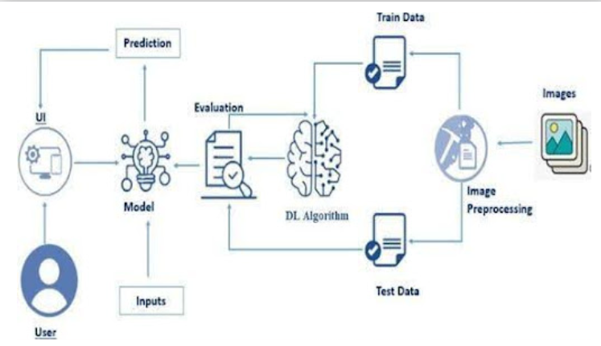

**Data Flow Design**

1. Image Upload: User uploads a blood smear image through the frontend.
2. Preprocessing: Image is resized, normalized, and reshaped for model input.
3. Model Prediction: The trained model predicts the cell type.
4. Response Display: The predicted class is shown on the UI with confidence scores.
5. (Optional): Logs stored in a database or file system.